Energy data report: Universal Analytics Project

Chris Coker
Mesa community college
CIS490
Dr. Conrad Dela Cruz
5/12/2026

Energy data report: Universal Analytics Project
This report examines how energy demand will evolve at the local level by integrating three interconnected analytical themes: global energy consumption trends, U.S. fuel-type forecasting, and business growth patterns across Phoenix-area ZIP codes. The central objective is to identify which communities face the greatest risk of energy demand outpacing current grid capacity.
Executive Summary
Global energy demand is on a steep upward trajectory, projected to more than double by 2050. The most rapid growth phase falls between 2020 and 2035, driven by industrialization, population expansion, electrification, and the explosive growth of digital infrastructure.
At the national level, the U.S. energy mix is undergoing significant structural change. Natural gas currently dominates, accounting for roughly 44% of projected 2026 electricity generation, while coal continues a steep decline. Wind and solar are expanding rapidly, but their share remains modest in the near term. Nuclear provides a stable but essentially flat baseline.
At the local level, business growth in the Phoenix metro area is concentrated in a small number of high-growth ZIP codes in Scottsdale, Mesa, Chandler, Gilbert, and the broader East Valley corridor. This geographic concentration of commercial activity creates specific, predictable pressure points on the power grid that demand targeted infrastructure investment.

Core Recommendations:
Conduct grid capacity assessments in the highest-growth Phoenix-area ZIP codes before commercial expansion outpaces supply. Prioritize renewable energy integration and distributed generation in these corridors. Use ZIP-code-level business growth data as a forward indicator for infrastructure needs rather than relying solely on historical consumption patterns.
SECTION 1: PURPOSE AND SCOPE OF ANALYSIS
Purpose
This project combines global energy demand trends with detailed, ZIP-code-level business growth data to pinpoint where local energy grids are most vulnerable to capacity strain. The goal is not simply to describe what is happening in the energy sector broadly, but to translate those trends into specific, actionable planning intelligence for municipal and utility decision-makers.
Scope of Analysis
The analysis looks at three levels:
- Global: Long-term worldwide energy use trends from 2010 to 2050, focusing on how usage changes and when it might level off.
- National: U.S. forecasts for different energy sources—like coal, natural gas, nuclear, wind, solar, and new types
- Local: Business growth in Phoenix-area ZIP codes, showing which neighborhoods are growing fastest and most likely to need more energy soon.

Data Sources and Methodology
Data Collection
Data was sourced from several government and intergovernmental organizations, spanning energy demand outlooks, energy sales and consumption records, and business activity data.
International Energy Outlook (Intergovernmental / EIA Long-Term Forecasts)
This dataset provides long-term projections and world-region benchmarks covering energy demand from 2010 through 2050.
U.S. Energy Information Administration (eia.gov)
The EIA API provided historical data on consumption patterns across fuel types.
U.S. Census Bureau: County Business Patterns (https://www.census.gov/programs-surveys/cbp.html)
The County Business Patterns dataset supplied ZIP-code-level commercial activity data, including business counts and growth trends across the Phoenix metropolitan area.
Analytical Methodology
The core analytical method applied across the datasets is time-series linear regression. This approach models the relationship between time and energy-related variables to identify directional trends, estimate growth rates, and produce forward-looking projections. Dashboard visualizations, including line charts, donut charts, bar charts, and geographic maps, were used to display and communicate patterns across all three analytical layers.

SECTION 2: KEY FINDINGS
Finding 1: Global Energy Demand Will Nearly Triple by 2050
The long-term global energy consumption forecast shows a consistent, sustained upward trend by 2050. Outside of a dip in energy demand during the COVID years, demand will increase. This aligns with the increase in demand from developing nations and for AI infrastructure.
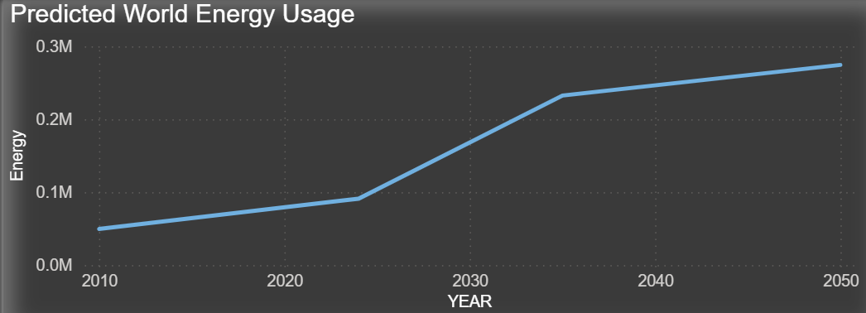

Finding 2: The U.S. Energy Mix Is in Active Transition
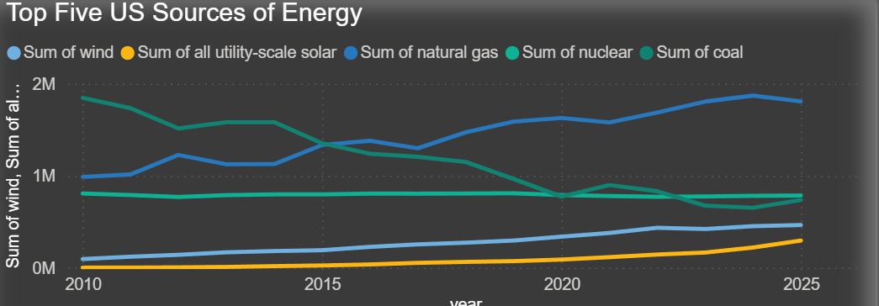

The composition of U.S. electricity generation is shifting materially. Natural gas has emerged as the dominant fuel, projected to account for approximately 44% of generation in 2026. This reflects its role as a transition fuel. Natural gas peaked around 2024-2025 and is expected to remain the backbone of U.S. electricity production throughout the near-term planning window.
Coal's decline is one of the clearest and most significant patterns in the dataset. It has fallen below nuclear in generation share and now represents only approximately 7% of projected output. This decline is structural, driven by plant retirements, policy pressure, and economic competition from cheaper natural gas and renewables. It is not expected to reverse.
Wind and solar are expanding rapidly. Wind shows consistent long-term growth with strong acceleration after 2020. Utility-scale solar started from a small base but is growing at a rapid percentage rate and is positioned to become increasingly significant within the decade. Nuclear remains stable, but with little large-scale expansion expected. 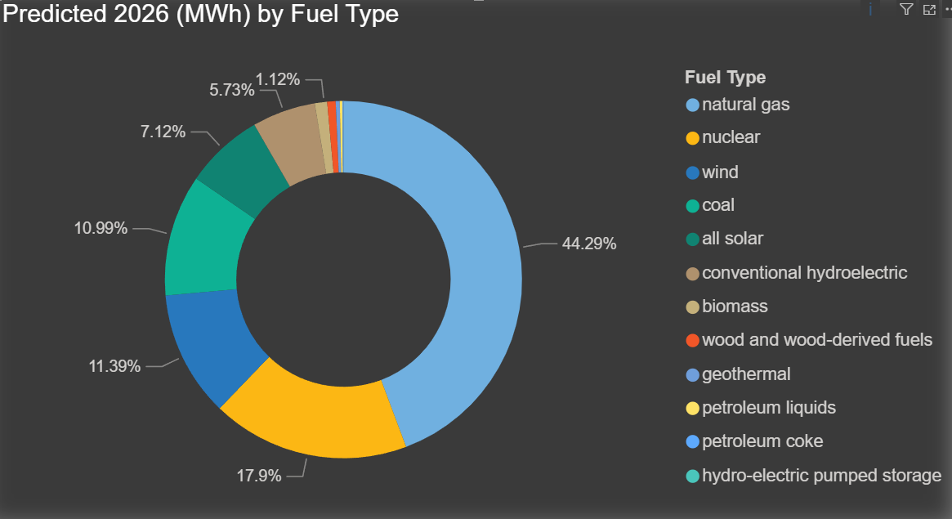
This is also counter to global consumption patterns, with coal still dominant alongside natural gas and hydrogen.
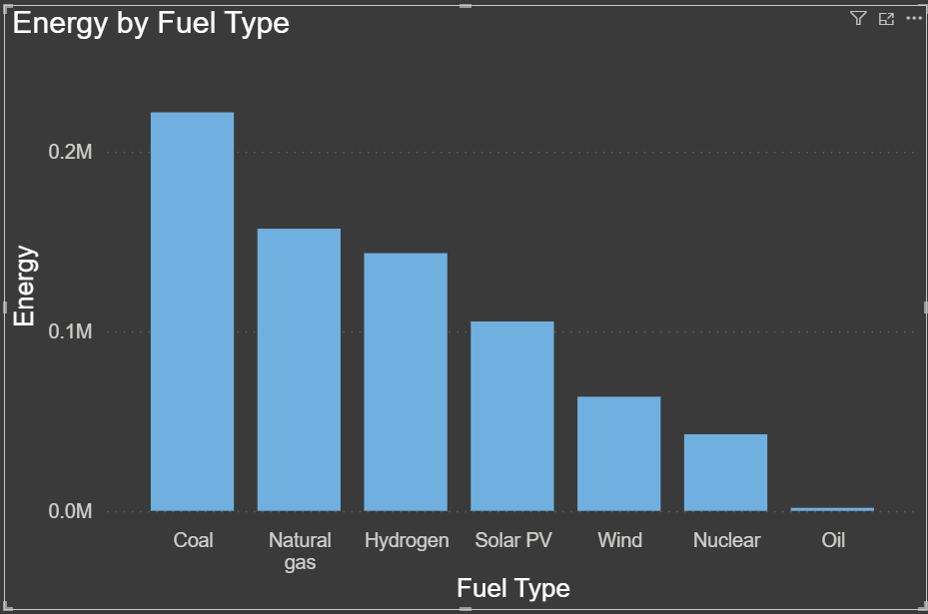

Finding 3: Phoenix-Area Business Growth Is Concentrated in Specific ZIP Codes
The local business growth analysis reveals a pattern of concentrated commercial expansion across a small number of Phoenix-area ZIP codes. The distribution is notably uneven: mean growth substantially exceeds median growth across the dataset, indicating that a handful of ZIP codes are responsible for a disproportionate share of total commercial activity growth.

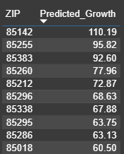

Geographically, the strongest growth clusters appear in the East Valley, centered on Scottsdale, Mesa, Chandler, and Gilbert. Here we see a shift of commercial activity away from dense urban cores toward newer, more accessible suburban corridors. Northern and eastern suburban areas show the clearest concentration of expansion.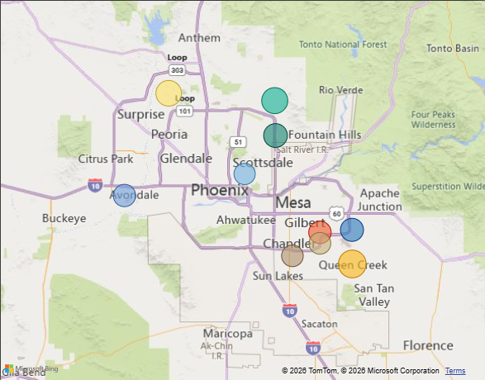
This pattern has direct implications for grid planning. Commercial business growth is a strong leading indicator of increased energy demand, particularly in sectors with high electrical loads such as retail, logistics, data centers, and light manufacturing. Identifying these ZIP codes creates a planning window for targeted infrastructure investment.
SECTION 3: BUSINESS IMPLICATIONS
For Grid Operators and Utilities
Rising global energy demand and local business growth are straining regional grids, especially in Phoenix’s fast-growing ZIP codes. Now is the time to invest in infrastructure. If utilities don’t upgrade capacity in high-growth areas soon, demand could outpace supply, causing reliability problems and higher costs for reactive grid fixes. Coal is declining, and natural gas now dominates, but its prices can change quickly. Utilities should start adding renewables and storage in growing suburbs to stay ahead of energy shifts.
For Municipal and Regional Planners
The geographic concentration of commercial growth in the East Valley is both an opportunity and a planning challenge. These communities are attracting investment and generating economic activity, but without coordinated infrastructure planning, growth can outpace the services. Municipal planners should treat business growth data as a forward indicator for energy infrastructure needs, incorporating it into capital improvement planning cycles. Zoning decisions, business attraction programs, and permitting processes should be coordinated with utility partners to ensure that electrical capacity is sequenced appropriately with commercial development timelines.
For Executive and Policy Stakeholders
The broader energy transition underway at the national level -- away from coal, toward natural gas and renewables. Investment in renewable generation and grid modernization in high-growth areas is not only environmentally aligned; it is financially prudent given the long-term trajectory of fuel costs and regulatory direction.
The data also underscores the importance of granular, local analysis. National and global trends provide context, but they do not answer the question of which specific communities need infrastructure investment and when. That answer requires the kind of ZIP-code-level integration this analysis provides.
SECTION 4: RECOMMENDATIONS
Recommendation 1: Conduct Immediate Grid Capacity Assessments in High-Growth ZIP Codes
Priority should be given to the ZIP codes in Scottsdale, Mesa, Chandler, and Gilbert that show the highest commercial growth rates in the dataset. Each should receive a formal grid capacity assessment comparing current infrastructure capacity against projected demand based on business growth trajectories. Assessments should be completed within the next 12 months to preserve an adequate planning and procurement window.
Recommendation 2: Develop a ZIP-Code-Level Demand Forecasting Model
The current analysis demonstrates the value of integrating business growth data with energy demand projections. A more formal, ongoing forecasting model should be developed that continuously updates demand projections for each high-growth area, as new business registration and commercial permit data become available. This model should be shared between utility partners and municipal planning departments.
Recommendation 3: Prioritize Renewable and Distributed Generation in Growth Corridors
New energy infrastructure investments in high-growth suburban corridors should incorporate renewable generation and distributed storage where feasible. This approach reduces long-term fuel-cost exposure and enhances grid resilience by reducing dependence on centralized transmission in areas with rapidly growing load profiles.
CONCLUSION
The Phoenix metro area, and the East Valley in particular, is experiencing exactly the kind of concentrated commercial expansion that stresses local grid infrastructure. The data is clear about where growth is occurring and what is driving it. The recommendations in this report are designed to help decision-makers act within that window: building the analytical infrastructure to monitor demand proactively, directing capital investment where it is most needed, and establishing the cross-institutional coordination that effective grid planning requires.

Works Cited

